Electronic Ballast

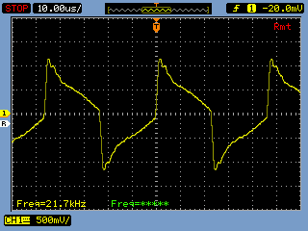

Measurement done using a Tektronix current probe

